Assignment (N+) Day-2(2)
Task-1:
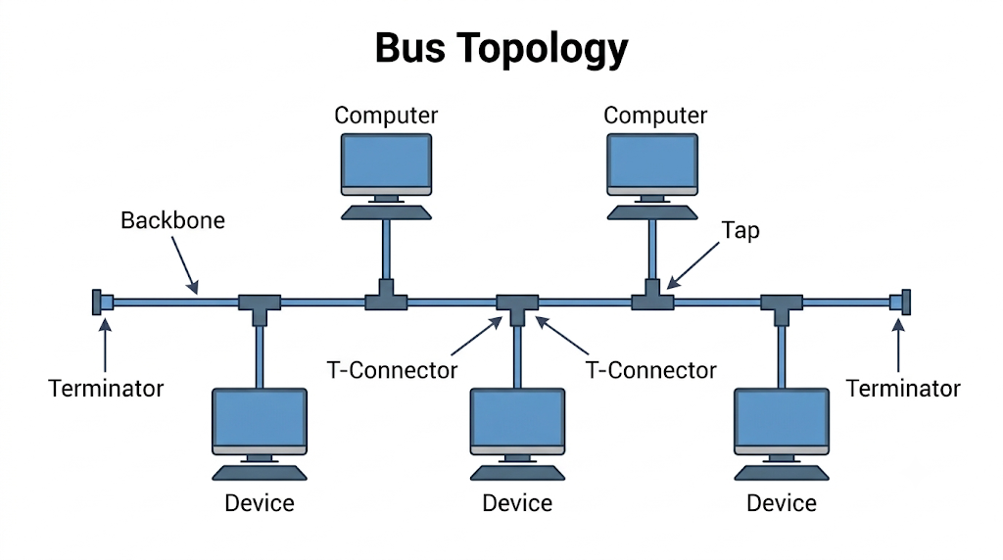
Real-world Example:
Bus topology is commonly used in Industrial Automation Systems (CAN bus) inside vehicles or manufacturing plants, where sensors and control units are connected in a line to share data over a single wiring system. Historically, it was also used in early cable television systems and first-generation office Ethernet networks (like 10BASE2) to run a single coaxial cable through a building to connect several computers.

Task-2:
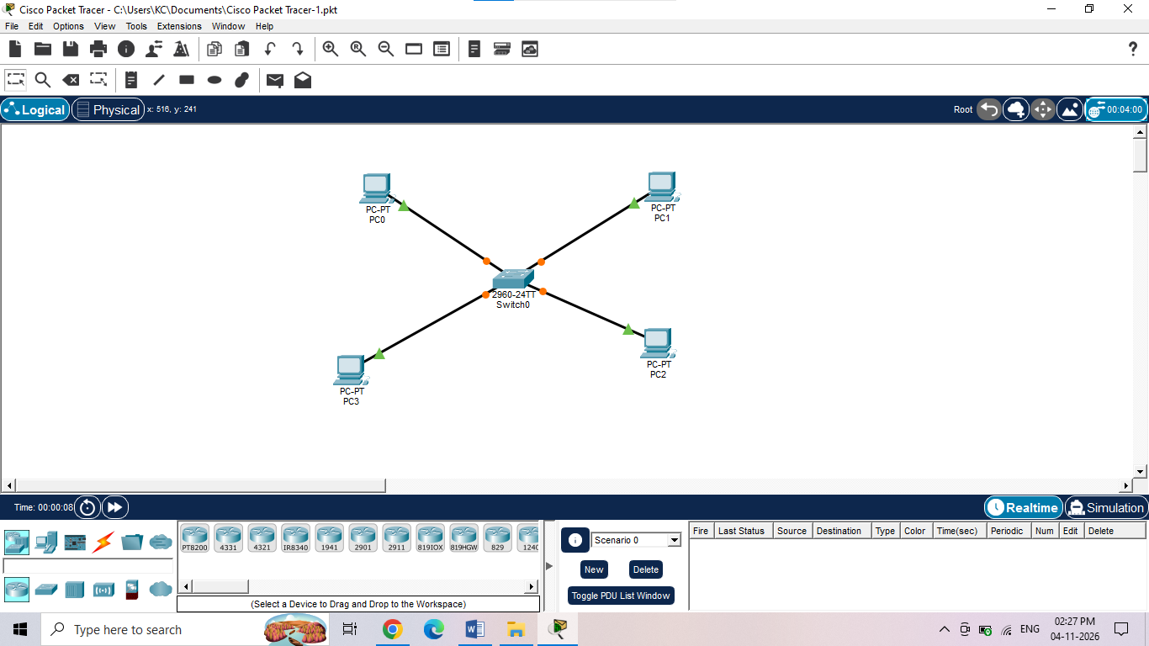

Task-3:
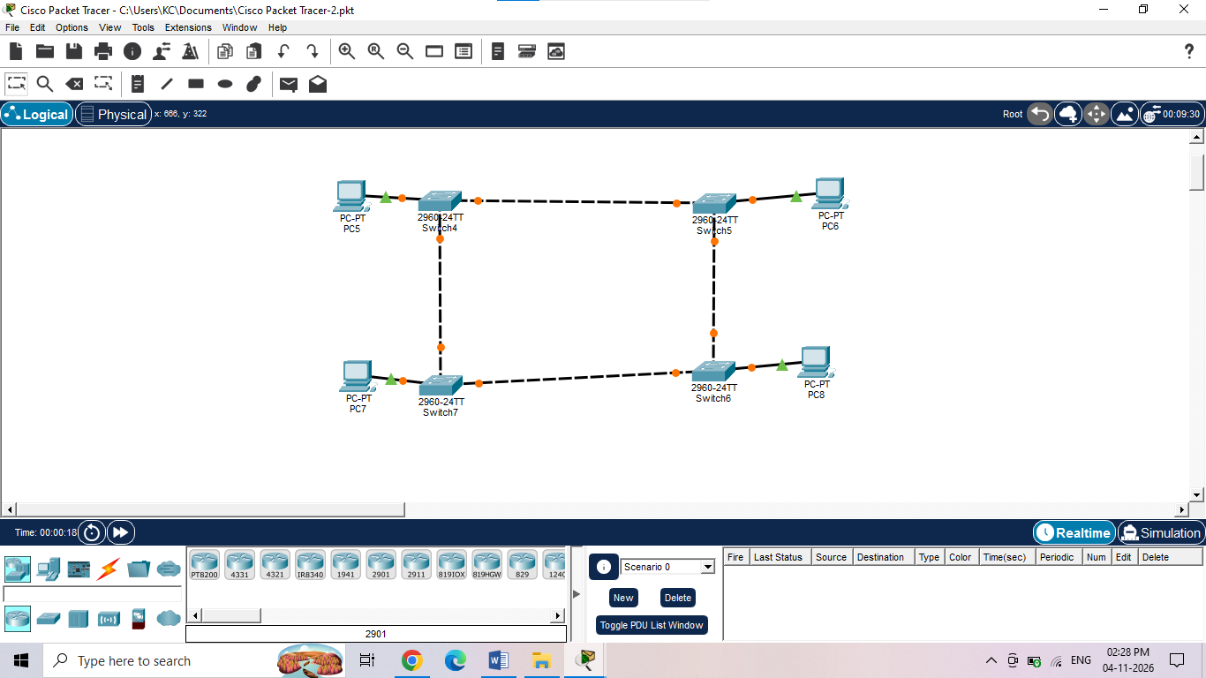

Task-4:
Mesh Topology Characteristics:
- High reliability: If one cable breaks, data automatically reroutes through other active connections.
- Handles heavy traffic: Multiple direct paths between devices prevent network bottlenecks.
- Expensive wiring: Requires a massive amount of cabling and network ports to connect every device together.
- Complex setup: Adding new devices or troubleshooting issues becomes highly complicated as the network grows.
Star Topology Characteristics:
- Easy installation: New devices can be added quickly by running a single cable to the central switch.
- Isolated node failures: If one computer's cable is cut, only that specific computer loses connection, leaving the rest of the network intact.
- Central point failure: If the central hub or switch breaks down, the entire network stops working.
- Hub dependency: Requires purchasing and maintaining a dedicated central networking device to function.

